CSA 283: Exam One

Name: ______________________________________ Section: _____ _____

Please write legibly. Ask questions if something is unclear.

You may use the Java 2 Platform Std. Ed. 6.0 documentation at http://java.sun.com/javase/6/docs/api/. You may not use any other documentation or notes.

Some useful formulas:
d_{trans} = L/R d_{prop} = d/s

L – packet length, R – link bandwidth, d – distance, s – propagation speed

Questions:

- List the five protocol layers of the internet in order from highest to lowest.
(5 points)

________________

________________

________________

________________

________________

- List the four sources of nodal delay. (4 points)

_________________

_________________

_________________

_________________

- Indicate which type of physical medium can be expect to have the highest bandwidth when considering twisted pair, coaxial cable, and fiber optic cable.
(2 points)

__________________________________
- State the definition of the following terms using one or two sentences. If it is an acronym, state what the letters in the acronym stand for and give a definition. (6 points)

a. Conical Hostname

b. Loss-tolerant application

c. TLD DNS Server:

- Below is an HTTP protocol message. Answer the questions about the message. (6 points)

HTTP/1.1 304 Not Modified\r\n
Date: Fri, 29 Sep 2006 19:32:34 GMT\r\n
Server: Apache/1.3.23 (Unix) (Red-Hat/Linux)\r\n Location: http://www.users.muohio.edu/~bachmann/\r\n
Keep-Alive: timeout=15, max=100\r\n
Connection: close\r\n

a. Was the message sent by a client or server? (circle one)

Client Server

b. What does the response line mean? What type of request would it be a response to?

c. Will additional HTTP messages be sent using the Socket Connection that was used to send and receive this message? Why or why not?

- SMTP can only transport one type of data. (4 points)

What type of data can be sent using SMTP?

__________________________________

What mechanism is used to overcome this limitation?

__________________________________

- Consider the following scenario:

A web browser opens a TCP connection to a web server in order to download a web page. Assume that the IP address of the server was cached on the local host. The browser sends a request message over the connection requesting the base HTML-file object. The web server responds by sending a response message containing the file. The browser parses the html file and finds five referenced objects. The browser opens a new Socket connection to the server to request and receive each of the referenced objects and from the web sever in parallel. Each of the Socket connections is left open to download additional objects. (6 points)

a. What type of HTTP connections is the browser using?

b. Assuming zero transmission time for all objects, approximately how many RTTs will it take to download the HTML file and the five referenced objects? (show your calculations)

c. If the browser used a single Socket to download the html file and all of the objects, how many RTTs would be required to get everything?

- Describe a circumstance under which queuing can be expected to occur at a router. What happens if the queue becomes too long? (3 points)

- Consider the following scenario:

You are designing a networked application. It is a peer to peer application in which peers exchange real-time sensor data. All peers must maintain a complete data history of the sensor data received by all other peers. Which transport layer protocol would you use to support this application? Why?
(3 points)

- List three reasons DNS uses a distributed database instead a centralized database. (3 points)

________________

________________

________________

- Use the constants below to answer the following questions. Show work for partial credit. Indicate the units for each answer. Show times to four decimal places. Assuming processing and queuing delays are negligible.

File Size 25 Mb 25,000 bits
Packet Size 0.5 Mb 500 bits
Link Bandwidth 20 Mbs 20,000 bits per second
Link Lengths 20 Kilometers 20,000 Meters
Propagation Speed 2.8 x 10⁵ Kms 2.8 x 10⁸ Meters per second

a. Calculate the propagation delay for a single link. (2 points)

b. Calculate the transmission delay for a single packet and a single router.
(2 points)

- Assume that host A is sending a 3KB file (consisting of three 1000 eight bit byte packets) to host B. The packets go through three links and two routers as shown below: (4 points)

Host A
Host B
1Mb/s
100Kb/s
1Mb/s
Router R1
Router R2

The three links have bandwidths of 1Mb/s (1,000,000 bits/second), 100Kb/s (100,000 bits/second), and 1Mb/s (1,000,000 bits/second). Assume that processing and propagation delays are negligible.

Calculate time needed for the file to reach host B.

- Consider the following scenario:

An email message is sent from sam@bar.com to juliette@contra.edu. The following three transfers of the message are performed.

Transfer One: An outlook email application running on 134.53.101.22 uploads the message to the mail server mail.foo.bar.com.

Transfer Two: mail.foo.bar.com contacts a mail server called po.contra.edu and uploads the message to po.contra.edu

Transfer Three: Eudora running on 123.99.200.14 is used to download the message from po.contra.edu .

For each of the transfers, name the application layer protocol that would normally be used. Specitfy which machine it the client and which is the server during the transfer (9 points)

Transfer One: Protocol: ______________

Client: ______________

Server: ______________

Transfer Two: Protocol: ______________

Client: ______________

Server: ______________

Transfer Three: Protocol: ______________

Client: ______________

Server: ______________

- Consider the following scenario:

An application running on host1.mu.edu wants to find the IP address of jenny.uc.edu. Assume that all DNS caches are initially empty and that all DNS servers (including the local server) use caching. Assume all queries are handled recursively. DNS server names are as follows:

TLD DNS server: dns.tld.edu
Local DNS server: dns.mu.edu
Authoritative DNS server: dns.uc.edu
Root DNS server: dns.root

- Draw arrows labeled with numbers to indicate the order of queries and responses sent before host1.mu.edu receives the IP address of jenny.uc.edu. The first arrow has already been drawn. (7 points)
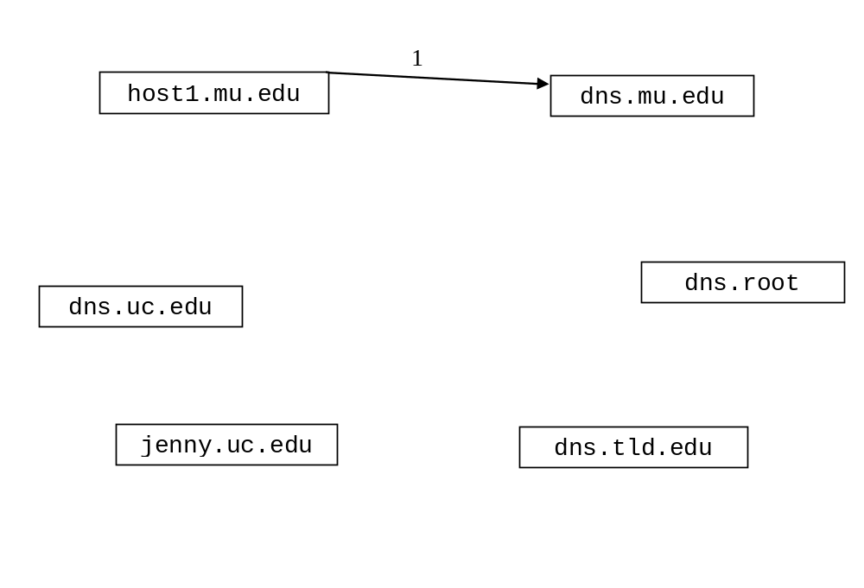
- Which server provides a resource record for containing the IP address of jenny.uc.edu? (2 points)

- In the above question, what type of resource record would be provided? (circle one) (2 points)

Type A Type NS Type CNAME Type MX
- After the sequence in part a. has occurred, suppose host2.mu.edu wants to find the IP address of fred.uc.edu. How would the sequence of events be different? (3 points)

- In question 13 above, before transfer two can take place, mail.foo.bar.com must determine the IP address for the mail server for the contra.edu domain. What type of resource record would mail.foo.bar.com initially request? (circle one) (2 points)

Type A Type NS Type CNAME Type MX

- Describe how content is found in a query flooding peer to peer file sharing system. What mechanism is used to keep queries from being sent to every peer in the network? (4 points)

- Complete the Server class on the next page. Do not worry about handling exceptions. Allow the main method to throw them to the OS. (18 points)
- Clients contact the Server and send some number of floats using TCP.
- The Server calculates the product of the positive numbers received and sends the product back to the client as a float.
- When the Server receives a negative number from a client, it will return the product of the positive numbers previously received from the client.
- The Server listens for clients on port number 7777.
- Do not use multi-threading. The server only needs to handle one client at a time. The Server should be able to handle multiple clients sequentially.

import java.io.*;
import java.net.*;

public class ProductServer {

public static void main(String[] args) throws Exception
{

} // end main
} // end ProductServer class
- Below is a fragment of a blast method for a game. Complete the method so that it sends data related to a “blast event” to an event server using UDP. The format and order for the data is as follows:

Code | X position | Y position | Blast Radius

Code for the blast data is 3. Code, X position, and Y position are of type int. Blast radius is of type float. The server is listening for on 131.1.22.6 and port number 6500. Your method must open and close the correct type of socket for each event. Do not write exception handling code. Let the method throw them. (14 points)

import java.io.*;
import java.net.*;
...
/**
* Sends blast event data. Message code is three. Give the position
* and radius for the explosion.
* @param x position of the detonation
* @param y position of the detonation
* @param r blast radius for the detonation
* @throws Exception
*/
public void blast( int x, int y, float r) throws Exception
{

} // end fireEvent

